FASD Fall 2016 Conference
Induction & Mentoring Action Plan
 | This Year: | Next Year:
Goals:
Current Reality:
Mind the Gaps:
Next Steps:
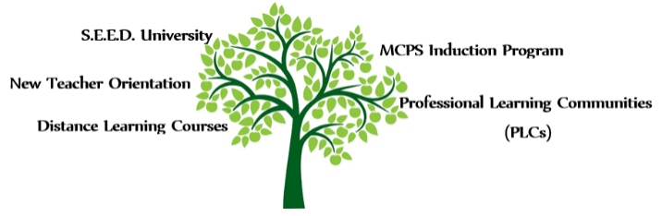
S.E.E.D. University: 2016 Fall Courses

Early Career Teachers: All teachers in their first 3 years of teaching are encouraged to attend S.E.E.D. University courses. Each course is aligned to a domain on the MCIES Rubric and focused on helping early career teachers improve both their instruction and subject area expertise. Participants will earn $25 per in-seat hour attended, as well as MIP points.

Peer Teachers: Peer teachers are encouraged to attend S.E.E.D. University courses along with their assigned new teacher. Each hour attended together may be logged on the Peer Teacher – PEC Teacher Time Log. Peer teachers will not be paid a stipend for attending the course, but MIP points may be earned for each in-seat hour attended.
Course Offerings: S.E.E.D. courses are designed to be a highly engaging time, where early career teachers learn to implement research-based and evidence-based strategies and practices. All sessions are aligned to the induction activities in found in the MCPS Induction S.E.E.D. Handbook, as well as with the Marion County Instructional Evaluation System (MCIES) domains.
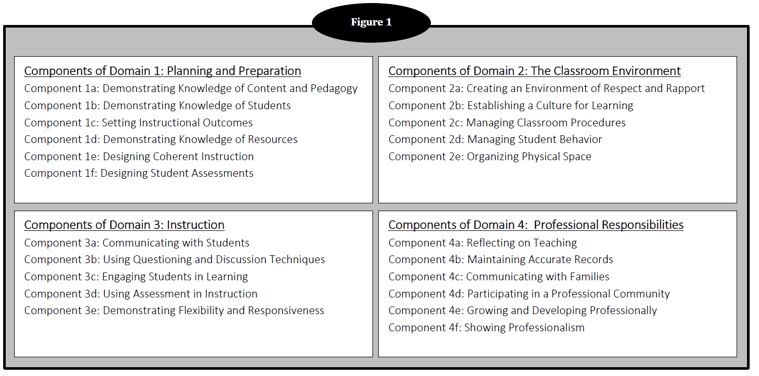
MCIES Domains:

Date(s) | Domain, Course Name, Section #, Description
Tues.,  9/6 | Domain 1: S.E.E.D. University-Mini-Seminar-Wonders Textbook (K & 1st grades ONLY) - S# 81083 (2 hrs.) Connect your classroom to core standards, inspiring literature, and the world with this comprehensive literacy program. Learn how the textbook helps teachers to focus on the same Essential Question, vocabulary, skills, and strategies throughout a given week.
Wed.,  9/7 | Domain 3: S.E.E.D. University- Mini-Seminar-ELA/SS-FSA Writing Rubric (6-12 grades ONLY) – S# 81065 (2 hrs.) This course will help teachers understand the rubric used to grade Baseline Writing Assignment, RWAs, DBQs, and CRLs. Secondary ELA and SS teachers will learn how the FSA rubric connects to their grade level LAFS. They will get the 2015-2016 updates on writing from the DOE and will have the opportunity to review and discuss the FSA Exemplar Essays.
Thurs.,  9/8 | Domain 1: S.E.E.D. University-Mini-Seminar-Wonders Textbook (2nd – 5th grades ONLY) - S# 81084 (2 hrs.) Connect your classroom to core standards, inspiring literature, and the world with this comprehensive literacy program. Learn how the textbook helps teachers to focus on the same Essential Question, vocabulary, skills, and strategies throughout a given week.
Mon.,  9/12,  9/19,  9/26 | Domain 2: S.E.E.D. University-Finding Your Discipline Style – S# 81067 (6 hrs.) Participants will uncover their discipline style in order to effectively approach classroom management. Through individualized plans, participants will be able to increase effective teaching and management strategies.
Tues.,  9/13 | Domain 1: S.E.E.D. University-Mini-Seminar-Elementary Math Textbook and Resources (K-5 ONLY) – S# 81072 (2 hrs.) Participants will learn how to efficiently use the plethora of resources the math department provides for effective core instruction. Resources include GoMath, Teaching Student Centered Mathematics, and Hands-On Standards.
Mon.,  9/19 | Domain 1: S.E.E.D. University-Mini-Seminar-HMH Collection E-textbook and Resource Training (6-12 grades ELA ONLY) – S# 81066 (2 hrs.) HMH Collection E-textbook and Resource Training will help teachers navigate the on-line dashboard for the e-textbook. This is where all the resources are housed for the HMH Collections textbook. This overview will help teachers learn what resources are available and most helpful for classroom instruction/differentiation.
All classes are from 5:00 PM – 7:00 PM at the Robert “Mack” Dunwoody Education Complex (bldg. 2) located at 1614 E. Fort King Street, Ocala, FL 34471
Date(s) | Domain, Course Name, Section #, Description
Mon.,  9/27,  10/4,  10/11 | Domain 3: S.E.E.D. University-Collaborative Structures – S# 81070 (6 hrs.) Participants will learn how to implement a variety of collaborative learning structures that will help actively engage students during whole group, small group, or partner learning.
Mon.,  10/3,  10/10,  10/17,  10/24 | Domain 2: S.E.E.D. University-Making the School to Home Connection: Effective Communication Strategies – S# 81093 (8 hrs.) Develop an effective communication system with parents to include documentation, proactive approaches, and navigating potential roadblocks.
Thurs., 10/06,  10/13,  10/20 | Domain 2: S.E.E.D. University-Prevention and Response to Discipline Concerns – S# 81068 (6 hours) Participants will uncover their discipline style in order to effectively approach classroom management. Through individualized plans, participants will be able to increase effective teaching and management strategies.
Tues., 10/25,  11/01 | Domain 3: S.E.E.D. University-Literacy Centers: the Basics! (K-5 ONLY) – S# 81086 (4 hrs.) Elementary teachers will examine Literacy Centers as they work from awareness to implementation level. The goal of this course is to provide teachers with the ability to effectively and efficiently plan and use classroom centers to differentiate instruction for all students.
All classes are from 5:00 PM – 7:00 PM at the Robert “Mack” Dunwoody Education Complex (bldg. 2) located at 1614 E. Fort King Street, Ocala, FL 34471

Date(s) | Domain, Course Name, Section #, Description
Thurs. 11/03,  11/10,  11/17 | Domain 2: S.E.E.D. University-Incentives and Intervention Through Instruction – S# 81069 (6 hrs.) This course will allow teachers to enhance their classroom management plans by implementing incentives within instruction such as PAT time and academic based incentives. These incentives will also allow teachers to identify need for intervention through instruction.
Tues.,  11/08 | Domain 1: S.E.E.D. University-Mini-Seminar-Elementary Math Textbook and Resources (K-5 ONLY) – S# 81073 (2 hrs.) Participants will learn how to efficiently use the plethora of resources the math department provides for effective core instruction. Resources include GoMath, Teaching Student Centered Mathematics, and Hands-On Standards.
Mon.,  11/07,  11/14,  11/21 | Domain 1: S.E.E.D. University-Effective Assignments and Assessments – S# 81071 (6 hrs.) Participants will learn to design lesson instruction so it is sequenced according to a learning progression that aligns to the highest level of thinking in the lesson learning goals and provides an effective assignment for students to apply their new understanding and skills.
Mon.,  11/14 | Domain 1: S.E.E.D. University-Mini-Seminar-Wonders Online Resources (K-5 ONLY) – S# 81087 (2 hrs.) This overview will help teachers learn how to navigate the on-line dashboard for the e-textbook, as well as what resources are available and most helpful for classroom instruction/differentiation.
Tues.,  11/15 | Domain 1: S.E.E.D. University-Mini-Seminar-Wonders Online Resources (K-5 ONLY) – S# 81089 (2 hrs.) This overview will help teachers learn how to navigate the on-line dashboard for the e-textbook, as well as what resources are available and most helpful for classroom instruction/differentiation.
All classes are from 5:00 PM – 7:00 PM at the Robert “Mack” Dunwoody Education Complex (bldg. 2) located at 1614 E. Fort King Street, Ocala, FL 34471
Please direct all questions regarding professional development courses to the MCPS Induction Team:
Logan Johnson (Elementary) – Logan.Johnson@marion.k12.fl.us / (352) 236-5017 (50117)
Lindsey Hampton (Secondary) – Lindsey.Hampton@marion.k12.fl.us / (352) 236-5013 (50113)

Professional Education Competence Program (PEC)
2016-2017
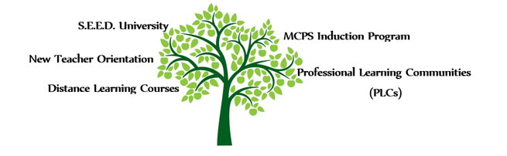

Definition
The Professional Education Competence Program (PEC) is required in Florida Statute 1012.56(8)(b): Instructional Staff must demonstrate mastery of professional education competencies. The “Long Term” PEC program is a full year (196 day) process. The “Short Term” PEC program is a half year (98 day) process. All PEC teachers will participate in the MCPS Educator Induction Program.

Required Coursework: MCPS Educator Induction Program
New teachers who are placed in the Professional Education Competence Program (PEC) are required to complete four sessions (24 hours) during their FIRST year of teaching.
Register for ONE date per session in TNL. Send TDEs to Shelley Greer, K-12 Academic Services (Funding Source: Referendum Budget).
MCPS Educator Induction: Classroom Environment (Session 1)
- Teachers will learn to establish an effective classroom environment using exemplary practices for establishing rules, expectations, and procedures.
MCPS Educator Induction: Effective Planning (Session 2)
- Teachers will learn to lesson plan effectively using a research-based framework that focuses on backward design and the consistent implementation of exemplary practices.
MCPS Educator Induction: Subject Area Expertise (Session 3)
- Teachers will build subject area expertise by developing content specific knowledge and skills.
MCPS Educator Induction: Accelerating Learning (Session 4)
- Teachers will learn to accelerate learning in order to meet the needs of all students.

All trainings will be held at the Robert “Mack” Dunwoody Educational Complex (bldg. 2) 1614 E. Fort King Street, Ocala, FL 34470

Registration Checklist:
- Confirm training date with administrator(s)
- Register in TNL
- Complete a TDE with your school secretary and send it to Shelley Greer, K-12 Academic Services (Funding Source: Referendum Budget)
- Secure a substitute with your school secretary
- Add a training date reminder to your Outlook Calendar
- Create a sub plan

Important Contact Information:
Please direct all questions regarding professional development courses to Lindsey Hampton or Logan Johnson at K-12 Academic Services. Contact Shelley Greer for questions regarding Temporary Duty Elsewhere (TDE) documentation.
Lindsey.Hampton@marion.k12.fl.us / 352-236-0513 (x. 50113)
Logan.Johnson@marion.k12.fl.us / 352-236-0517 (x. 50117)
Shelley.Greer@marion.k12.fl.us / 352-236-0593 (x. 50273)

Training reminders are posted on the Early Career Teachers page on the K-12 Academic Services Portal.
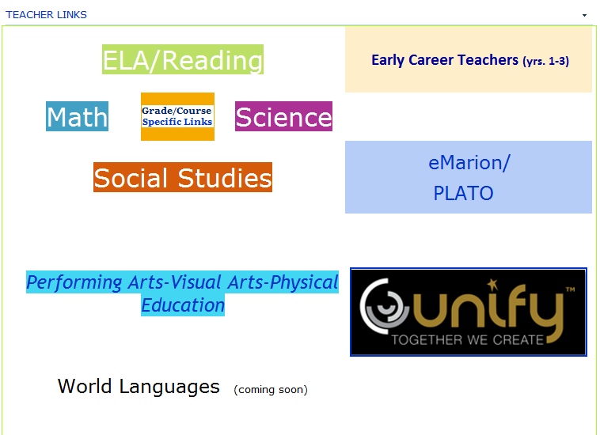

Proposed Induction Activities Timeline
The following activities are a good place to start, but are not the only things you can do. Consult with your school administration for more ideas.
Schedule | Suggested Topics / Activities | PEC Educator initials | Time/  Date
Pre-school through Month 1  Pre-school through Month 1 | Level 1: Orientation Activities  - Tour the school. Take note of key areas—media center, cafeteria, clinic, PE field, etc. Ask for map if necessary. Find out procedures for sending students to the media center and clinic.  - Introduce yourself to grade-level, content area, or fellow hallway educators. If you’re on a team, find out when they will be meeting and what you need to bring. If you’re not sure if you’re on a team, ask your administrator.  - Find out procedures for obtaining supplies and photocopying—ordering and copying budget/paper allocation, online procedures for ordering supplies—what basics do you need to be ready for Day 1 (stapler, tape dispenser, pens, dry erase, etc.)?  - Find out procedures for sick leave or requesting time off—TDE and leave forms, online sub request, requirements for prior approval.  - Develop substitute lesson plans/emergency lesson plans. Create organized sub folder/binder complete with plans and daily schedule. Leave in an easily accessible place (having them in a brightly colored folder is helpful).  - Find out student and educator lunch procedures in the cafeteria—payment, lunch line, student tables, educators’ lounge/eating area.  - Find out the expectations for attire—is there a spirit or jean day?  - Explore the K-12 Academic Services New Teacher Page on K-12 Academic Services portal (MyMarionPortal/Curriculum and Instruction/K-12 Academic Services/New Teacher.  Level 2: Mentoring Activities  - Topic for Mentor Discussions: Successful Start--How do I prepare myself for the first week? The first nine weeks?  - Locate your curriculum map(s), testing calendar(s), report card/grading guidelines. All should be accessible from the Curriculum and Instruction portal. Determine how you will use, plan for, and incorporate all of them.  - Teaching Environment Profile  - Getting to know your students; complete a class profile  - Understand where to find student data (SMS, Performance Matters, Cumulative folder/guidance records)—use the Student Detail Report from Performance Matters and look at students’ cumulative folders in the guidance department.  - Do any of your students receive accommodations on an IEP or 504? What are they? How should you document those in your plans?  Level 3: Professional Growth Activities  - Learning Walks / Instructional Rounds  Topic: Domain 2: Classroom Environment  - Classroom observations using Domain 2 Self-Reflection Guide  - S.E.E.D. University Courses  Domain 2: Domain 2: Classroom Environment  Courses could include:  - The First Days of School, by Harry & Rosemary Wong (12 MIP Points)  - Tools for Teaching: Classroom Management Video Series (12 MIP Points)  - Classroom Management for Elementary Teachers (6 MIP Points)  - De-Escalation of Behavioral Issues in the Classroom (ESE CREDIT) (12 MIP Points)

Schedule | Suggested Topics / Activities | PEC Educator initials | Time/  Date
Months  2-3  Months  2-3 | Level 1: Orientation Activities  - Create a schedule for grading papers and entering grades. Interim report cards will be issued mid-way through the first nine weeks (mid-September). Also, parents can access their students’ grades, so it’s best to stay as current as possible. Set aside a particular time to do it and set a goal for yourself each time (e.g. “I’ll grade for 30 minutes,” or “I’ll grade two class periods”)  - Prepare for parent-educator conferences.  - Read the Marion County Instructional Evaluation System (MCIES) rubric. Pay close attention to the Effective and Highly Effective categories. Focus on Domains 2 and 3.  - Seeking certification, Out-of-Field, or needing Reading Endorsement? Talk to your administrator about what you need to do or who you need to contact to get started satisfying the requirements. There are yearly hour requirements so it’s best to get started ASAP.  - Take a classroom inventory of supplies. Last month, you checked for the basics. What else do you need? (chart tablets, crayons, construction paper, handwriting paper, sentence strips, markers, vis-à-vis pens, etc.) Order necessary items.  - Optional: Attend an after-school function (parent night, curriculum fair, etc.)  Level 2: Mentoring Activities  - Topic for Mentor Discussions: Planning & Grading--What’s the most effective way to plan? Do you have any time management tips to save time planning and grading?  - Planning for first nine weeks—big ideas, essential questions, mapping.  - Develop a behavior management plan. Find out if the school has a plan or focus (PBS, character development, etc.). Determine what behaviors receive discipline beyond the classroom (call to parent, referral, dean, administrator intervention)  - Prepare for first interim reporting period. Find out how to enter grades.  - Create a system for making and keeping track of parent contact: a form, notebook, email listserv (use a sign in sheet at Open House to gather emails), electronic spreadsheet, etc. Make parent contact regarding something positive.  - Develop your Instructional Deliberate Practice goals  - Prepare for end of first 9 weeks. Seek assistance and training on how to properly enter grades.  Level 3: Professional Growth Activities  - Learning Walks / Instructional Rounds  Topic: Domain 2: Classroom Environment  - Classroom observations using Domain 2 Self-Reflection Guide  - S.E.E.D. University Courses  Topic: Domain 2: Classroom Environment  Courses could include:  - The First Days of School, by Harry & Rosemary Wong (12 MIP Points)  - Tools for Teaching: Classroom Management Video Series (12 MIP Points)  - Classroom Management for Elementary Teachers (6 MIP Points)  - De-Escalation of Behavioral Issues in the Classroom (ESE CREDIT) (12 MIP Points)

Schedule | Suggested Topics / Activities | PEC Educator initials | Time/  Date
Months  4-5  Months  4-5 | Level 1: Orientation Activities  - Consider your classroom arrangement. What’s working well at this point? What’s not working well at this point? Make adjustments you think will help streamline classroom activities. Are your materials well-managed? Can students easily and independently access what they need?  - Read: http://www.readingrockets.org/article/311/ This can also be found on the portal in the “Classroom Environment” folder.  - Analyze the success of your paper collection and distribution strategies. Is there a more efficient way to collect papers and return graded work?  - Research efficient ways of grading and returning papers. Start here: http://thecornerstoneforeducators.com/free-resources/routines-and-procedures/papers and http://thecornerstoneforeducators.com/free-resources/organization/paper-trap  - Do you display student work? If not yet, set up a system for displaying work. What types of things will you display? What criteria have to be met for display? How long will it stay up? Who will be responsible for putting it up and removing it? How should students treat the work that’s on display? Communicate this system to your students. If you’ve been displaying work, is your system effective?  - Some ideas: http://clutterfreeclassroom.blogspot.com/2011/08/student-work-displays-setting-up.html  - Consider the opportunities your students have to work together in pairs or in small groups. Think about the last time you had them work together. Analyze what went well and what didn’t go well. What do you plan to do differently next time?  - Go through this free, self-paced workshop on cooperative learning: http://www.thirteen.org/edonline/concept2class/coopcollab/index.html  Level 2: Mentoring Activities  - Topic for Mentor Discussions: What can I do if I’m not happy with my classroom management at this point? How can I successfully make changes now, even though we’re this far into the school year? When would be an appropriate time to make the changes? How can I train my students to adapt to the change? How can I monitor that the changes I’ve made are successful?  - Domain 2 Guided Observation—follow the directions on the form (self-assess, set a goal, go observe, make changes to your practice)  - Reflection on First Semester  - Revisit the self-assessment for Domain 2 and complete it again. Note growth. Note areas in need of improvement.  - Gather the feedback from administrative walk-throughs  - Develop an action plan for areas of improvement during the second semester. Follow the directions on the Action Planning form.  Level 3: Professional Growth Activities  - Learning Walks / Instructional Rounds  Topic: Domain 1: Effective Planning, Instruction & Assessment  - Classroom observations using Domain 1 Self-Reflection Guide  - S.E.E.D. University Courses  Topic: Domain 1: Effective Planning, Instruction & Assessment  Courses could include:  - LEARNING-FOCUSED Effective Assignments and Assessments (6 MIP Points)  - Distance Learning Moodle Courses:  Topic: Domain 1: Effective Planning, Instruction & Assessment  Courses could include:  - K-5 Curriculum Maps (1 MIP Point) or 6-12 Curriculum Maps (1 MIP Point)  - K-12 Book Study: Assignments Matter: Making Connections that Help Students Meet Standards (24 MIP Points)  Suggested LEARNING-FOCUSED Moodle Courses: (3 MIP Points)  - MCPS Educator Induction: Effective Planning-Learning Goals and Essential Questions  - MCPS Educator Induction: Effective Planning-Effective Lesson Instruction  - MCPS Educator Induction: Effective Planning-Learning Focused Lessons

Schedule | Suggested Topics / Activities | PEC Educator initials | Time/  Date
Months  6-10  Months  6-10 | Level 1: Orientation Activities  - Think about your homework assignments, policy, and student completion. Is it effective? Do you want to do it differently? Visit the Homework folder on the portal for resources.  - Assess your planning practices. Are you developing plans based on standards and learning outcomes? Are you planning ahead? Do you use assessments to guide your planning? Are you planning for maximum engagement of students?  - Academic Standards workshop: http://www.thirteen.org/edonline/concept2class/standards/index.html  - Assessment, Evaluation, and Curriculum Redesign workshop: http://www.thirteen.org/edonline/concept2class/assessment/index.html  - Other useful workshops with ideas for planning, assessment, and instruction:  - Interdisciplinary Learning workshop: http://www.thirteen.org/edonline/concept2class/interdisciplinary/index.html  - Inquiry-based learning workshop: http://www.thirteen.org/edonline/concept2class/inquiry/index.html  - Multiple Intelligences workshop: http://www.thirteen.org/edonline/concept2class/mi/index.html  Level 2: Mentoring Activities  - Topic for Mentor Discussions: How do you use assessment to plan? What types of formative assessment do you use? How do you plan for summative assessments? Do you use any performance-based assessments?  - Domain 3 Guided Observation—follow the directions on the form (self-assess, set a goal, go observe, make changes to your practice)  - Domain 1 Self-Reflection on Planning—follow the directions on the form (self-assess, set a goal, explore best practices)  - Reflection on Second Semester  - Revisit the self-assessment and complete it again. Note growth. Note areas in need of improvement.  - Gather the feedback from administrative walk-throughs  - Develop an action plan for areas of improvement in preparation for next year  Level 3: Professional Growth Activities  - Learning Walks / Instructional Rounds  Topic: Domain 3: Instruction  - Classroom observations using Domain 3 Self-Reflection Guide  - S.E.E.D. University professional learning courses held at K-12 Academic Services  Topic: Domain 3: Instruction  Courses could include:  - Using Centers for Differentiated Instruction (12 MIP Points)  - Higher Order Thinking: Increasing Rigor in Lessons (6 MIP Points)  - Distance Learning Moodle Courses:  Topic: Domain 3: Instruction  Courses could include:  - 3-12 Book Study: Summarization in Any Subject (24 MIP Points)  - K-12 Book Study: Total Participation Techniques (24 MIP Points)  Suggested LEARNING-FOCUSED Moodle Courses: (3 MIP Points)  - MCPS Educator Induction: Collaborative Pairs  - MCPS Educator Induction: Graphic Organizers  - MCPS Educator Induction: Advance Organizers  - MCPS Educator Induction: Activating Strategies  - MCPS Educator Induction: Vocabulary Instruction

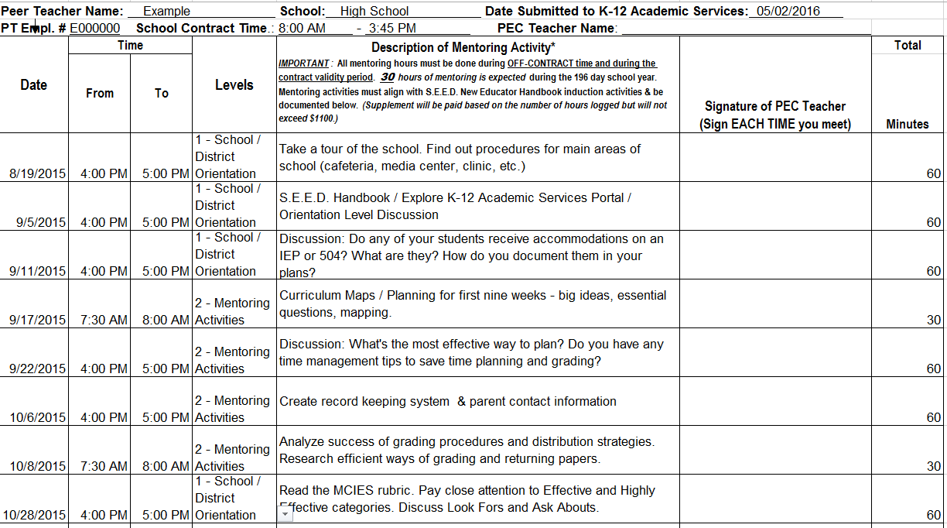
All activities are documented on the Peer Teacher–PEC Teacher Time Log:

2016 – 2017
“ProfessionalGrowth@K-12AcademicServices”
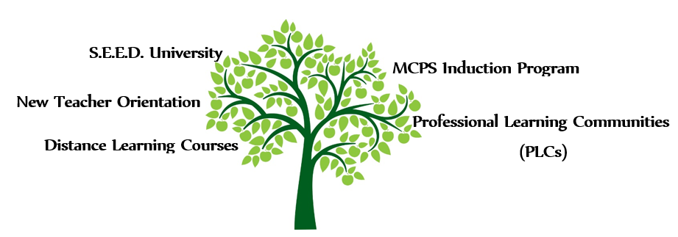

Monday, August 1, 2016
Marion Technical Institute (MTI) Student Union
1614 E. Fort King Street
Ocala, FL 34471

8:00 AM to 3:30 PM

Registration
8:00 AM – 8:30 AM

Breakout Sessions

Multi-Tiered System of Support (MTSS) Overview
“Meet & Greet” Content Area Program Specialists
Classroom Management: Day One
Prioritizing Professional Responsibilities
Ask an Expert: Administrator Panel
Tech Shout Outs! – Technology for Interactive Learning
Navigating the MCPS Desktop Portal
Exceptional Student Education (ESE) & 504 Services Legal Responsibilities

Breakfast Provided by School Notes

All Attendees must wear their MCPS ID Badge

ATTENDANCE IS VOLUNTARY
Participants will be compensated $25 per hour

2016-2017
New Teacher Orientation
Required Attendance

Tuesday, August 2nd, 2016
College of Central Florida
The Ewers Center
3001 SW College Road
Ocala, FL 34474

7:00 AM to 12:30 PM

Registration
7:00 AM – 7:30 AM

Welcome Session
Address from Superintendent Mr. Tomyn
New to Teaching Support
Public Education Foundation
Ethics and Professional Conduct Overview
Marion Education Association (MEA)

Other Sessions Include
Ask a Colleague: Teacher Panel
K-12 Academic Services Resources
Risk Management - Barrett, Liner, & Buss, LLC / Payroll
Marion County Instructional Evaluation System Overview
Positive Behavioral Support in the Classroom

The Public Education Foundation of Marion County

Breakfast Provided by MEA

All Attendees must wear their MCPS ID Badge

Please note that ATTENDANCE IS REQUIRED by all new teachers
#GoTeach
@MCPSNewTeachers
Example Newsletter:

