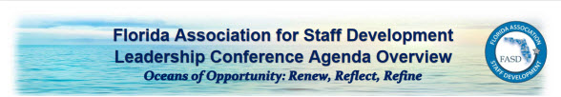

Dear FASD Members,

We hope this email finds you safe after Irma’s devastation all over the state. We are writing to let you know that the upcoming FASDLC conference in St. Petersburg at the Tradewinds Resort has been cancelled. The Tradewinds needs the facility and space for Florida Recovery teams there to help communities in Southwest Florida. They have canceled all events for the next 2-3 weeks, including ours.
We have confirmed that those of you with reservations within the FASD room block do NOT need to do anything to cancel your rooms. All FASD blocked rooms have been cancelled automatically.

We will be in touch soon with information about how to proceed with our annual elections, the announcement of our FASD Awards, and information about plans for the 2018 Spring Forum in April or May. We will miss seeing all of you, but we know this is a good decision due to the extent of the devastation around our entire state.

Stay safe,

Alyson Adams
FASD President

Brenda Crouch, Carol Milton, & Joanna Johnson
FASDLC Conference Chairs

Debbie Cooke
FASD Executive Director

