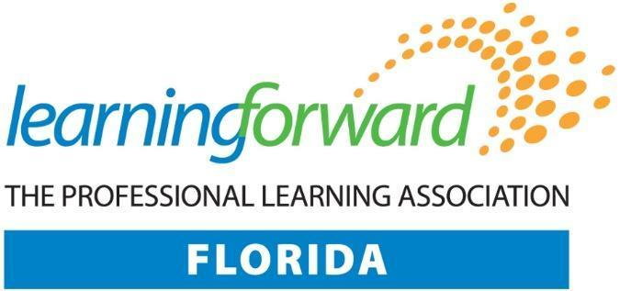
Board Members 2022-23
Debbie Cooke  Executive Director |  |  |  |  |  |  |  | Shannon Burgess  FDOE Representative
Shane Fairbairn  President |  | Amanda March  Immediate Past President |  | Naomi Church  President Elect |  | Paula Clark  Secretary |  | Cathy Starling  Treasurer
Barbara Eubanks  Director, Region I |  | Kristi Richburg  Director, Region II |  | Andi Canaday  Director, Region III |  | Lauri Christopher  Director, Region IV |  | Isela Rodriguez  Director, Region V
Zina Berman  Director at Large |  | Shannon Bogle  Director at Large |  | Carmen Concepcion  Director at Large |  | Janice Franceschi  Director at Large |  | Donna Garcia  Director at Large
Cele Oldham  Director at Large |  | Wafa Picciolo  Director at Large |  | Heather Platt  Director at Large |  | Claire Steele  Director at Large |  | Kwani Woods  Director at Large

Regional Directors serve members within their specified regions.
Directors at Large chair Board Committees not specifically assigned in the bylaws and support Regional Directors in their respective regions.

